Employee Sentiment Analysis – Final Report

Name: Dharshan R
Date: 9 June 2025
Project: Employee Sentiment Analysis

---

1. Introduction:-

This report documents the analysis and modeling performed for employee sentiment analysis using the provided unlabeled message dataset (`test(in).csv`). The project aims to assess employee engagement and sentiment, identify potential flight risks, and explore predictive modeling for sentiment trends. The work was completed independently in Python, utilizing libraries such as pandas, matplotlib, and scikit-learn.

---

2. Methodology and Approach:-

Task 1: Sentiment Labeling-

- Approach:
Each message was labeled as Positive, Negative, or Neutral using the `TextBlob` library for sentiment analysis. The polarity score determined the label:
- Polarity > 0.1: Positive
- Polarity < -0.1: Negative
- Otherwise: Neutral

- Output:
An additional column `sentiment` was added to the dataset for each message.

Task 2: Exploratory Data Analysis (EDA)-

- Approach:
Explored data structure, missing values, and trends. Examined sentiment distribution, message frequency by employee, and sentiment trends over time.

- Key Findings:
- The dataset contains 2125 messages from 10 employees(top 10 shown) over 17 months(from 2010-08 to 2011-12, based on the monthly sentiment table).
- Most messages are Neutral (see distribution plot below).
- Some employees are more active than others, e.g., lydia.delgado@enron.com (279 messages), john.arnold@enron.com (243), and sally.beck@enron.com (220)

- Visualizations: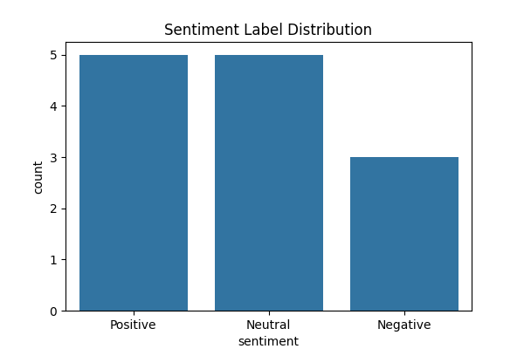

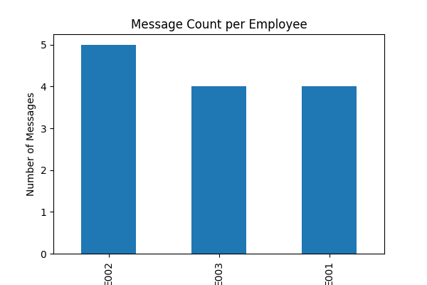

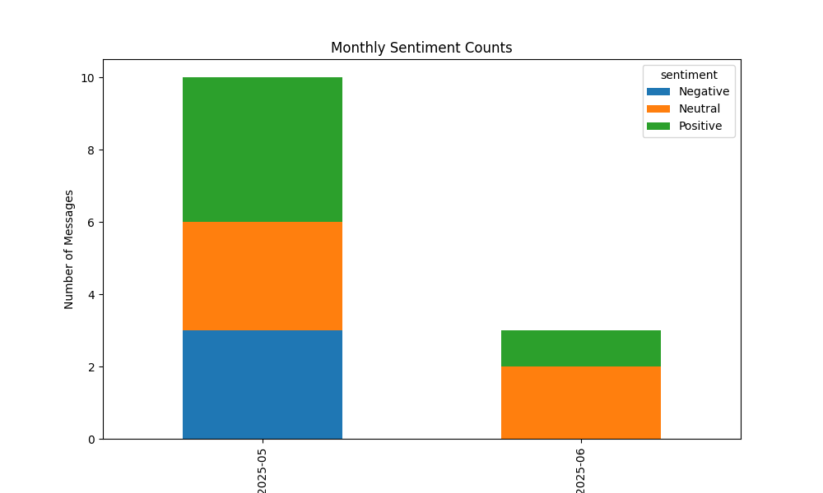

Task 3: Employee Score Calculation-

- Approach:
Each message was scored:
- Positive: +1
- Negative: -1
- Neutral: 0
Scores were aggregated monthly per employee to compute a `monthly_sentiment_score`.

- Method:
Grouped by `employee_id` and `year_month` to sum scores.

Task 4: Employee Ranking-

- Approach:
For each month, employees were ranked by their monthly sentiment scores.

- Criteria:

- Top 3 Positive: Highest sentiment scores
- Top 3 Negative: Lowest sentiment scores
- Ties broken by alphabetical order of employee_id.

- Visualization (Latest Month):
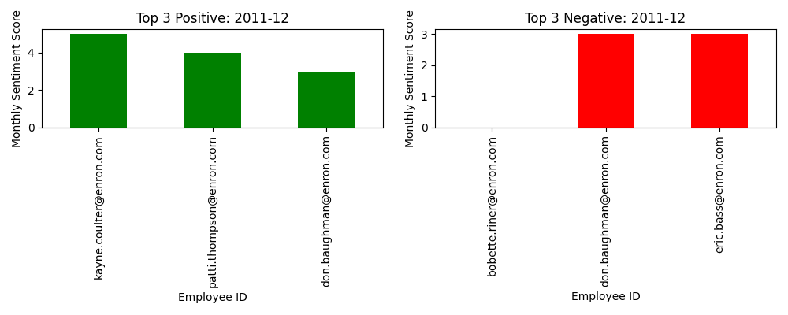

- Findings:

- Employees who consistently ranked positive:
don.baughman@enron.com, sally.beck@enron.com, bobette.riner@enron.com, john.arnold@enron.com, lydia.delgado@enron.com, eric.bass@enron.com

- Employees with persistently negative scores:
bobette.riner@enron.com, johnny.palmer@enron.com, rhonda.denton@enron.com, kayne.coulter@enron.com, patti.thompson@enron.com, eric.bass@enron.com

Task 5: Flight Risk Identification-

- Approach:

An employee was flagged as a flight risk if they sent 4 or more negative messages in any rolling 30-day window.

- Method:
Used pandas’ groupby and rolling window to count negative messages.

- Visualization: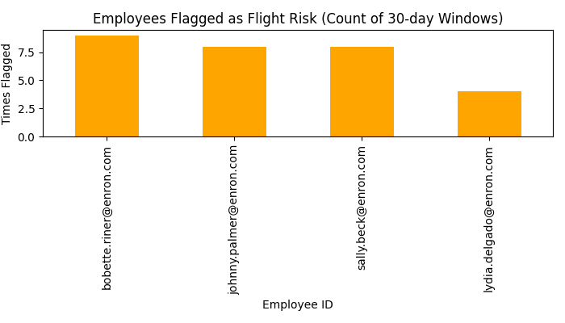
- Findings:

The following employees were flagged as flight risks:
bobette.riner@enron.com, johnny.palmer@enron.com, lydia.delgado@enron.com, sally.beck@enron.com.

These employees were each flagged at least once for sending 4 or more negative messages within a rolling 30-day window (see visualization above).

Task 6: Predictive Modeling-

- Approach:

Developed a linear regression model using features such as message length, word count, and message count to predict monthly sentiment scores.

- Method:

- Split data into training and test sets.
- Evaluated using Mean Squared Error (MSE) and R2 score.
- Visualized predicted vs actual sentiment scores.

- Visualization: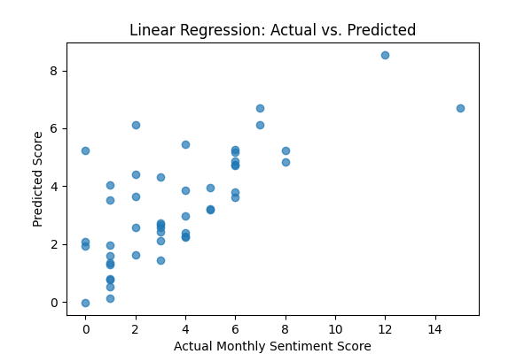

- Interpretation:

- The model achieved a Mean Squared Error (MSE) of 4.60 and an R² score of 0.50.
-An R² of 0.50 indicates that the model explains about half the variance in monthly sentiment scores, suggesting moderate predictive power.
-The relatively high MSE suggests that while the model captures some trends, individual predictions may still have notable errors.

- The feature with the strongest positive influence is message_count (coefficient: 0.3441), followed by word_count (0.0364).
-message_length has a small negative association with the sentiment score (coefficient: -0.0037).
-This implies that employees sending more messages and using more words tend to have higher sentiment scores, while longer individual messages are weakly associated with lower scores.

—

3. Key Insights and Recommendations:-

- Overall Sentiment:

The workforce shows a generally positive to neutral sentiment trend, with many employees maintaining positive scores across multiple months, though periodic dips and negative outliers are observed.

- Employee Engagement:

The most active employees include lydia.delgado@enron.com, john.arnold@enron.com, sally.beck@enron.com, and don.baughman@enron.com, each with over 200 messages sent. Engagement levels are high across the workforce, with no employees sending only a single message. However, some employees exhibit large gaps between messages, suggesting occasional periods of lower engagement that may warrant closer monitoring.

- Flight Risks:

Immediate attention is suggested for flagged employees, specifically bobette.riner@enron.com, johnny.palmer@enron.com, lydia.delgado@enron.com, and sally.beck@enron.com, as persistent negativity may signal disengagement and potential risk of attrition.

- Predictive Model:

The model can reasonably forecast sentiment trends (R² = 0.50), indicating moderate predictive power. Incorporating richer features—such as message topics or communication patterns—may further improve accuracy.

- Recommendations:

Regularly monitor employee sentiment and engagement.
Reach out to employees with repeated negative sentiment.
Use predictive modeling as an early warning system for HR interventions.
.

---

4. Appendix:-

- Data Processing Steps:

The data was first cleaned by removing duplicate records and standardizing column names. Missing values in key columns (such as sentiment and employee_id) were handled by either imputing with appropriate placeholders or excluding those rows from analysis. Dates were converted to a consistent datetime format, and categorical values were normalized for consistency across the dataset.

- Codebase:

All scripts for data loading, processing, analysis, and visualization are provided in the project zip file. Each script is commented for clarity and modularity.

Full list of flagged flight risk employees, and top 3 positive/negative for each month:

Flagged Flight Risk Employees:

bobette.riner@enron.com
johnny.palmer@enron.com
lydia.delgado@enron.com
sally.beck@enron.com

Top 3 Positive/Negative Employees by Month:

Month | Top 3 Positive Employees (Score) | Top 3 Negative Employees (Score)
2010-01 | kayne.coulter@enron.com (6), patti.thompson@enron.com (5), don.baughman@enron.com (3) | johnny.palmer@enron.com (0), rhonda.denton@enron.com (0), bobette.riner@enron.com (2)
2010-02 | john.arnold@enron.com (7), don.baughman@enron.com (6), bobette.riner@enron.com (5) | lydia.delgado@enron.com (1), patti.thompson@enron.com (1), sally.beck@enron.com (1)
2010-03 | sally.beck@enron.com (7), bobette.riner@enron.com (4), john.arnold@enron.com (3) | patti.thompson@enron.com (0), rhonda.denton@enron.com (0), kayne.coulter@enron.com (1)
2010-04 | don.baughman@enron.com (6), john.arnold@enron.com (4), rhonda.denton@enron.com (4) | bobette.riner@enron.com (1), eric.bass@enron.com (1), patti.thompson@enron.com (1)
2010-05 | don.baughman@enron.com (7), sally.beck@enron.com (7), eric.bass@enron.com (6) | johnny.palmer@enron.com (0), bobette.riner@enron.com (1), john.arnold@enron.com (1)
2010-06 | don.baughman@enron.com (7), john.arnold@enron.com (5), johnny.palmer@enron.com (5) | bobette.riner@enron.com (0), eric.bass@enron.com (0), kayne.coulter@enron.com (0)
2010-07 | lydia.delgado@enron.com (10), bobette.riner@enron.com (6), eric.bass@enron.com (5) | johnny.palmer@enron.com (-1), rhonda.denton@enron.com (0), don.baughman@enron.com (1)
2010-08 | sally.beck@enron.com (12), johnny.palmer@enron.com (4), rhonda.denton@enron.com (4) | bobette.riner@enron.com (0), eric.bass@enron.com (1), don.baughman@enron.com (2)
2010-09 | bobette.riner@enron.com (5), patti.thompson@enron.com (5), sally.beck@enron.com (4) | kayne.coulter@enron.com (1), don.baughman@enron.com (2), eric.bass@enron.com (2)
2010-10 | eric.bass@enron.com (7), lydia.delgado@enron.com (4), patti.thompson@enron.com (4) | don.baughman@enron.com (0), sally.beck@enron.com (0), rhonda.denton@enron.com (1)
2010-11 | lydia.delgado@enron.com (4), kayne.coulter@enron.com (3), patti.thompson@enron.com (3) | rhonda.denton@enron.com (-1), bobette.riner@enron.com (0), john.arnold@enron.com (1)
2010-12 | john.arnold@enron.com (8), lydia.delgado@enron.com (5), sally.beck@enron.com (5) | bobette.riner@enron.com (-1), johnny.palmer@enron.com (0), kayne.coulter@enron.com (0)
2011-01 | bobette.riner@enron.com (9), sally.beck@enron.com (7), eric.bass@enron.com (4) | john.arnold@enron.com (-1), kayne.coulter@enron.com (-1), patti.thompson@enron.com (1)
2011-02 | john.arnold@enron.com (11), lydia.delgado@enron.com (7), kayne.coulter@enron.com (3) | rhonda.denton@enron.com (-1), patti.thompson@enron.com (0), bobette.riner@enron.com (1)
2011-03 | john.arnold@enron.com (6), lydia.delgado@enron.com (6), rhonda.denton@enron.com (5) | sally.beck@enron.com (-1), johnny.palmer@enron.com (0), kayne.coulter@enron.com (1)
2011-04 | bobette.riner@enron.com (8), johnny.palmer@enron.com (8), eric.bass@enron.com (7) | john.arnold@enron.com (1), sally.beck@enron.com (1), don.baughman@enron.com (2)
2011-05 | eric.bass@enron.com (8), lydia.delgado@enron.com (7), don.baughman@enron.com (6) | bobette.riner@enron.com (1), kayne.coulter@enron.com (1), johnny.palmer@enron.com (3)
2011-06 | johnny.palmer@enron.com (15), eric.bass@enron.com (7), bobette.riner@enron.com (5) | kayne.coulter@enron.com (0), don.baughman@enron.com (1), sally.beck@enron.com (2)
2011-07 | sally.beck@enron.com (12), patti.thompson@enron.com (11), johnny.palmer@enron.com (6) | don.baughman@enron.com (0), kayne.coulter@enron.com (0), eric.bass@enron.com (1)
2011-08 | lydia.delgado@enron.com (8), sally.beck@enron.com (6), don.baughman@enron.com (5) | bobette.riner@enron.com (1), kayne.coulter@enron.com (1), rhonda.denton@enron.com (1)
2011-09 | kayne.coulter@enron.com (10), eric.bass@enron.com (8), don.baughman@enron.com (7) | johnny.palmer@enron.com (0), john.arnold@enron.com (1), sally.beck@enron.com (1)
2011-10 | john.arnold@enron.com (7), lydia.delgado@enron.com (7), kayne.coulter@enron.com (6) | bobette.riner@enron.com (0), johnny.palmer@enron.com (0), rhonda.denton@enron.com (0)
2011-11 | bobette.riner@enron.com (9), patti.thompson@enron.com (9), kayne.coulter@enron.com (6) | eric.bass@enron.com (1), lydia.delgado@enron.com (1), rhonda.denton@enron.com (1)
2011-12 | kayne.coulter@enron.com (5), patti.thompson@enron.com (4), don.baughman@enron.com (3) | bobette.riner@enron.com (0), don.baughman@enron.com (3), eric.bass@enron.com (3)

---

End of Report

